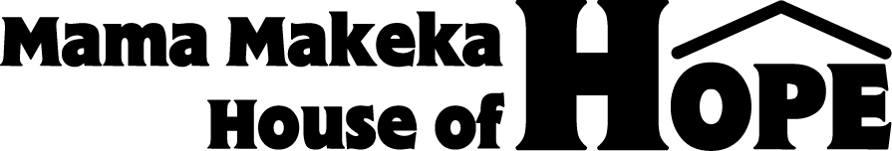
4921 E. Townsend Avenue, Fresno, CA. 93727;
(559) 797-2609; Pakisa@mmhhope.org; www.mmhhope.org 568 Campbell Street, Winnipeg, Manitoba, R3N 1C1
Kinshasa Center for
Professional Resourcing
Mama Makeka House of Hope is envisioned as a resource center in Kinshasa, DR Congo for:
- Teachers, doctors, nurses, community development workers, peacebuilding agents, and school administrators and for professional students in Kinshasa, providing a library, internet access, and a retreat center for weekend and summer seminars and courses;
- Visitors from anywhere in Congo and neighboring countries to stay for short periods of educational activities;
- Foreigners visiting the country to work on various mission and development projects;
- Other activities related to health, education and peacebuilding to be developed, monitored, and evaluated.
Phase I – “Chez Milo” Initial Base for Ministries in DRC
- Land preparation 30,000
- Service building and storage 45,000
- Chez Milo – initial base for ministry 150,000
- Garden and small farm 30,000
Total 255,000*
*All figures in US Dollars
All contributions made to Mama Makeka House of Hope for this project are tax deductible.

